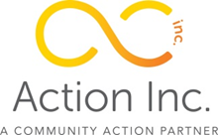
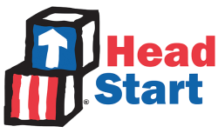

“Action Inc is a non-profit organization dedicated to the development of pathways out of poverty in Southwest Montana by developing innovative, community-based, collaborative solutions.”

Teacher Assistant—Butte Head Start
Employment/FLSA Status: Full-Time/Non-Exempt/Seasonal
Wage: DOE

Position Summary:
We are currently seeking an energetic person to join our team in the position of Head Start Teacher Assistant. Through a respectful, constructive, and energetic style guided by the objectives of the organization, the position plays an integral role in the administration of Community Action programs. The successful candidate is responsible for assisting with the instruction of preschool children in activities designed to promote social, emotional, physical and intellectual growth. This position will be a member of the Mining City Head Start #1 Local #4419,MEA-MFT,AFT,AFL-CIO.

Duties and Responsibilities:
- Assist the classroom teacher in supervising preschool children in activities that are designed to promote social, emotional, physical and intellectual growth; as defined by the Head Start Performance Standards, as well as, the Head Start Act.
- Responsible for the implementation of School Readiness activities that promote a successful transition to Kindergarten.

Qualifications:
- Child Development Associate (CDA); or
- Associate Degree in Early Childhood; or
- Bachelor’s Degree in a related field; or
- 1 year of experience and must obtain CDA within 2 years.

Benefits:
- Optional group medical, vision, dental and life insurance. Benefit includes employer contribution.
- Retirement benefits through the Montana Public Employees Retirement System (PERS). Benefit includes employer contribution.

How to Apply: Applications are available at our website www.butteassistanceprograms.org/careers, Action Inc, 25 W. Silver, Butte, MT 59701; or at Butte Head Start 1000 S. Arizona. Submit completed application and resume to Action Inc. or Butte Head Start. Email jpaul@hrc12.org with any questions, or to request an electronic application.

Action Inc. is an Equal Opportunity Employer
Women, minorities, veterans, and individuals with disabilities are encouraged to apply.

